

EXPERIMENT 2

Execute and display the results for the following commands in Kali Linux Operating Systems: less command more command vi command

AIM
To Execute and display the results for the following commands in Kali Linux Operating Systems: less command more command vi command

PROCEDURE
- Open Kali Linux
- Open terminal
- Create @ile and insert content
  - touch EH.txt -- press Enter
  - nano EH.txt -- press Enter
  - Type the following
Unit 1 topics
Introduction to Ethical Hacking Types of Hackers and Their Roles Ethics of Ethical Hacking
Ethical Hacking and the Legal System Proper and Responsible Disclosure
  - Press Ctrl + O -- press Enter
  - Press Ctrl + X
- more command
  - more EH.txt -- press Enter
- less command
  - less EH.txt -- press Enter
  - press q
- vi command
  - vi EH.txt -- press Enter
  - press i
  - Navigate the curser to Unit 1. Make sure the curser points 'U' then press enter. Now type "Welcome to Ethical Hacking"
  - press Ese
  - :wq -- press Enter

OUTPUT
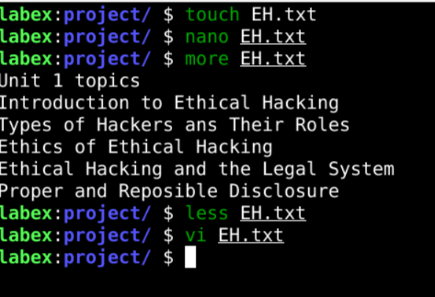
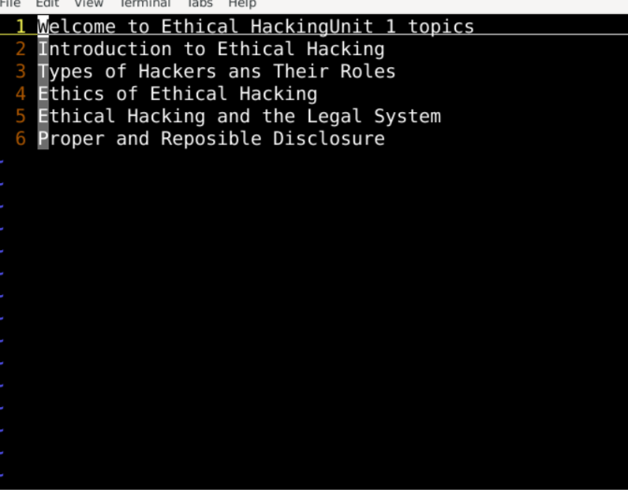

RESULT
the results for the following commands in Kali Linux Operating Systems: less command more command vi command was successfully executed

